Actually text will be changed and updated before sign off. The below is mainly to get the layout correct.

**Homepage**

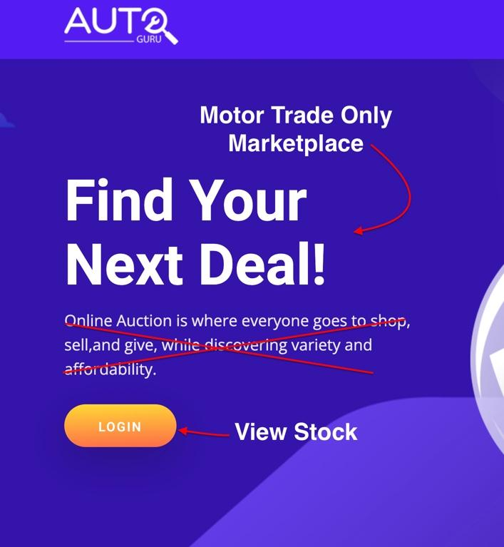

1. Replace text above with:

AutoGuru Trade Sales lets you replenish your forecourt on demand.

With listings closing every hour and ‘buy it now’ stock available 24/7 from a host of sources.

1. Move the preview box down and add text box above

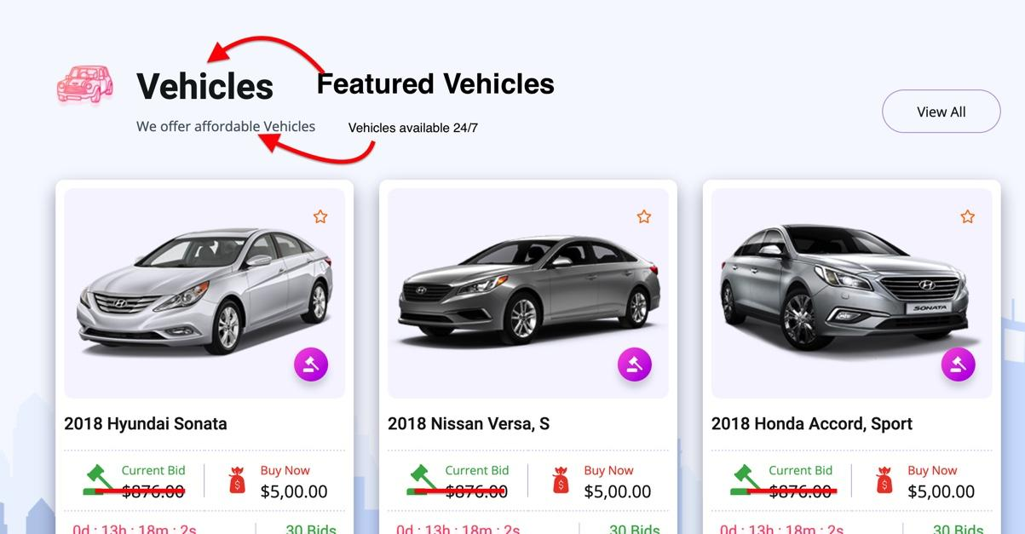

Text:

## **Buy with confidence**

Dealers have been using our reports on thousands of vehicles to gather further insights.

All vehicles listed be that from fleets, franchised dealers or privates are test driven, inspected and graded before being accepted into the sales channel. To insure further insight all vehicles undergo a further inspection and condition report before going live on our site. Our goal is to allow buyers to accurately price any repairs or prep needed resulting in a profitable experience for both sides.

See if you can add the below image to one of the sides of the text to break it up, (I’ll provide a clearer one if it can be added)

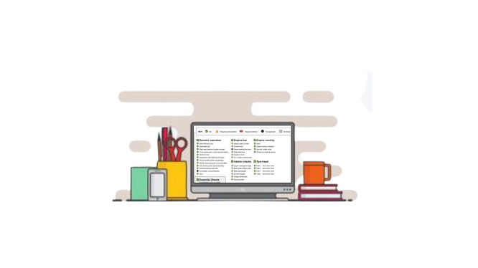

1. Additional Text box

## 

## **Convenience**

AutoGuru trade sales is designed for the digital era. That means you can buy stock to fill your forecourt at any time from anywhere. After purchase of the vehicle transport to your premises is organised by NVD.

1. Additional text box with Sign Up button beneath

## **Take us for a test drive**

Curious about what you see? Then why not sign up now

**Stock Page**

Looks good for the main part

Remove the featured car section at the top:

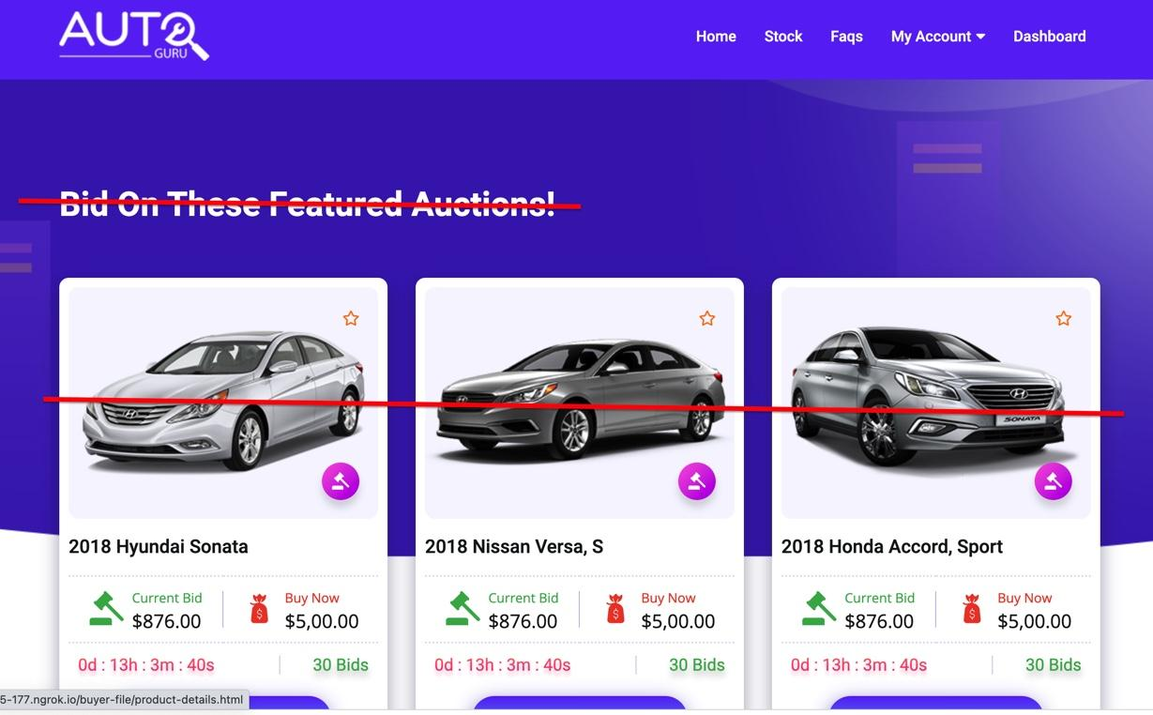

And remove the subscribe bit from the site



**Vehicle Listings**

I can't see what is inside the listing on the test site as there is a 404 error but I’m working from the original template link.

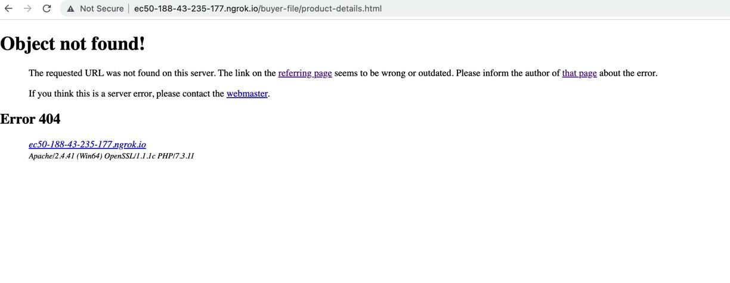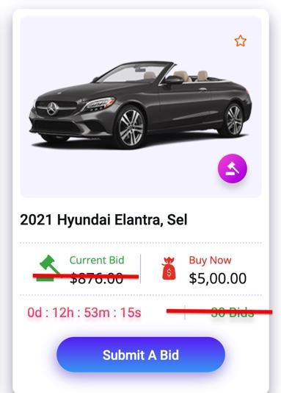

On the listing can we hide the current bid and bid the number of bids from public view. I’m hoping that buyers will make blind bids not knowing what other buyers have offered. I’m not sure if this is possible without looking at a live version of the template.

Change text in “Submit A Bid” to “Submit A Offer”

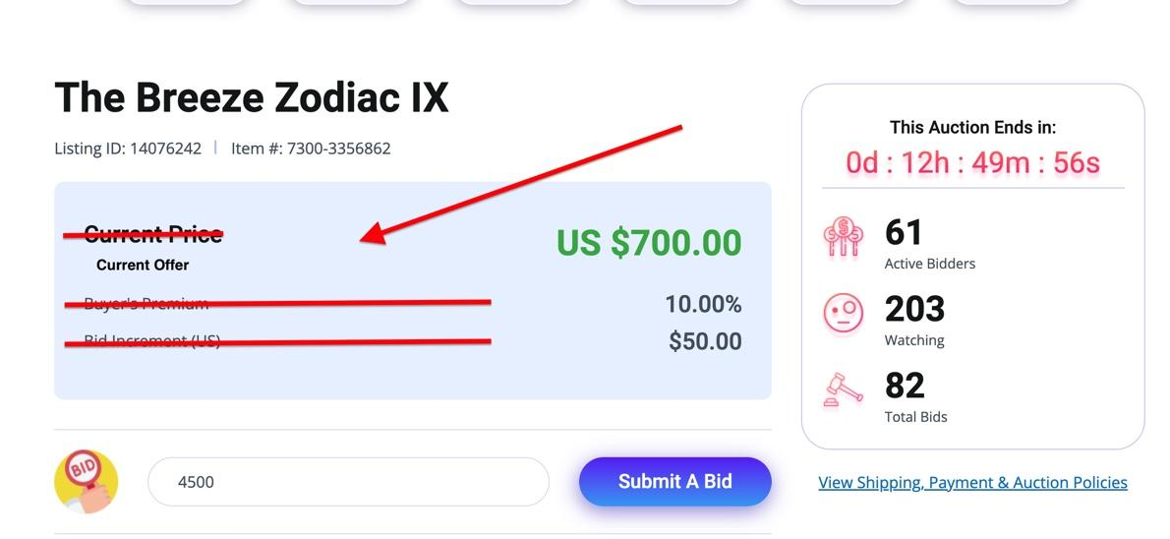

Im not sure on the functionality but can this section show the users offer on the vehicle?